

**CS2102**

**Database Systems**

**PROJECT REPORT**

*PetCare18*

Group 18

Chen Penghao (A0122017Y)

Kuang Ming (A0148043L)

Xia Rui (A0148000Y)

Xie Peiyi (A0141123B)

1. **Introduction**

Pets are often treated as important as a member of the family of their owners. However, sometimes pet owners might be unable to take care of their pets for various reasons. It would be a worrying time if the pet was not properly taken care of, such as not timely fed, or the feces not properly cleaned. It would be helpful if the pets could be taken care of by another caregiver, such that the owner would be less worried of their pets’ situations.

PetCare, our web application, made use of PHP and PostgreSQL to address to this problem, by connecting pet owners and care givers in an interactive and real-time manner.

1. **Project Overview**

Here are the technical details of our project:

|  |  |
| --- | --- |
| Web server | Bitnami |
| Server Language | PHP |
| Database management system used | PostgreSQL |
| External packages installed | Bootstrap CSS, JQuery |

1. **Entity Relation Diagram**

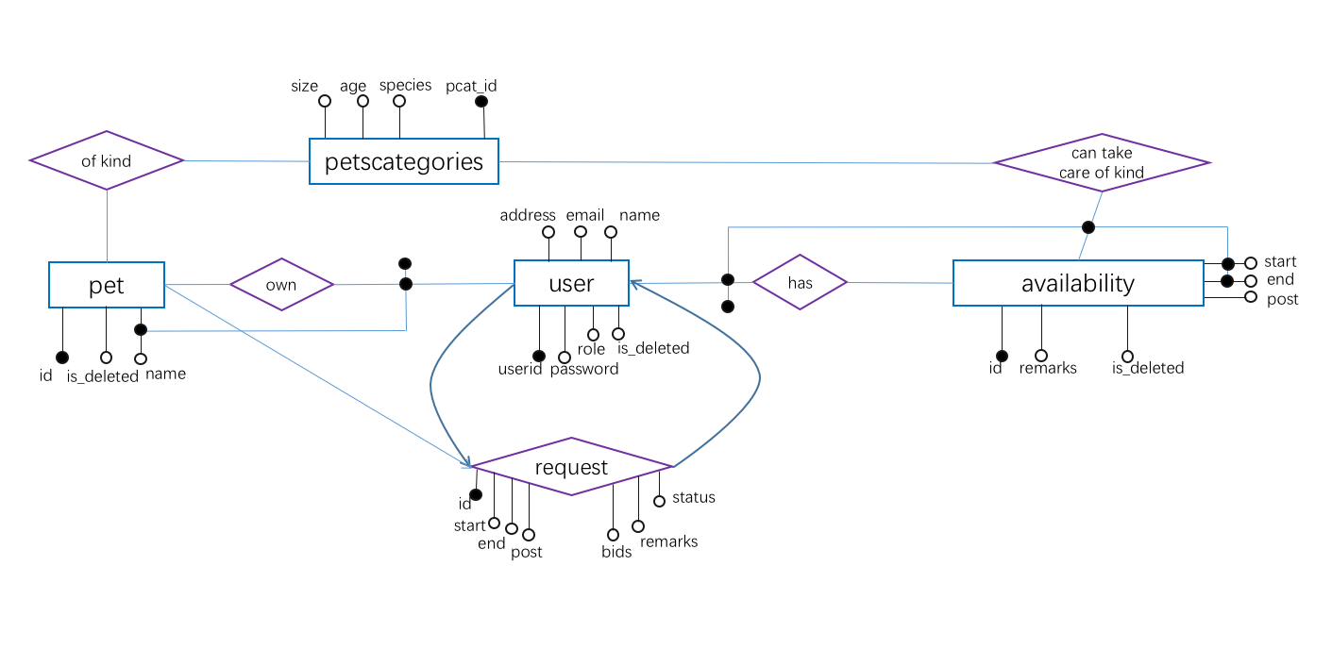

1. **Relational Schema**

4.1 Tables

**CREATE TABLE** petcategory(  
 **pcat_id INT PRIMARY KEY DEFAULT** nextval(**'pcat_seq'**),  
 **age VARCHAR**(10),  
 **size VARCHAR**(20),  
 **species VARCHAR**(30)  
);  
  
**CREATE TABLE** pet_user(  
 **user_id INT PRIMARY KEY DEFAULT** nextval(**'user_id_seq'**),  
 **name VARCHAR**(64) **NOT NULL**,  
 **password VARCHAR**(64) **NOT NULL**,  
 **email VARCHAR**(64) **UNIQUE**,  
 **address VARCHAR**(64),  
 **role VARCHAR**(10) **DEFAULT 'normal' CONSTRAINT** CHK_role **CHECK** (**role in** (**'admin'**, **'normal'**)),  
 **is_deleted** BOOLEAN **DEFAULT FALSE**);  
  
**CREATE TABLE** pet(  
 **pets_id INT PRIMARY KEY DEFAULT** nextval(**'pets_id_seq'**),  
 **owner_id INT REFERENCES** pet_user(**user_id**) **ON DELETE CASCADE**,  
 **pcat_id INT REFERENCES** petcategory(**pcat_id**) **ON DELETE CASCADE ON UPDATE CASCADE**,  
 **pet_name VARCHAR**(64),  
 **is_deleted** BOOLEAN **DEFAULT FALSE**,  
 **UNIQUE** (**owner_id**, **pet_name**)  
);  
  
**CREATE TABLE** availability(  
 **avail_id INT PRIMARY KEY DEFAULT** nextval(**'avail_id_seq'**),  
 **post_time timestamp NOT NULL DEFAULT** *current_timestamp*,  
 **start_time TIMESTAMP NOT NULL**,  
 **end_time TIMESTAMP NOT NULL**,  
 **pcat_id INT REFERENCES** petcategory(**pcat_id**) **ON DELETE CASCADE ON UPDATE CASCADE**,  
 **taker_id INT REFERENCES** pet_user(**user_id**) **ON DELETE CASCADE**,  
 **remarks VARCHAR**(64) **DEFAULT 'No'**,  
 **is_deleted** BOOLEAN **DEFAULT FALSE**,  
 **UNIQUE** (**start_time**, **end_time**, **pcat_id**, **taker_id**),  
 **CONSTRAINT** CHK_start_end **CHECK** (**end_time** > **start_time**),  
 **CONSTRAINT** CHK_post **CHECK** (**start_time** > **post_time**)  
);  
  
**CREATE TABLE** request(  
 **request_id INT PRIMARY KEY DEFAULT** nextval(**'request_id_seq'**),  
 **owner_id INT REFERENCES** pet_user(**user_id**) **ON DELETE CASCADE**,  
 **taker_id INT REFERENCES** pet_user(**user_id**) **ON DELETE CASCADE**,  
 **post_time TIMESTAMP NOT NULL DEFAULT** *current_timestamp*,  
 **care_begin TIMESTAMP NOT NULL**,  
 **care_end TIMESTAMP NOT NULL**,  
 **remarks VARCHAR**(64) **DEFAULT 'No'**,  
 **bids NUMERIC NOT NULL**,  
 **pets_id INT REFERENCES** pet(**pets_id**) **ON DELETE CASCADE ON UPDATE CASCADE**,  
 **slot VARCHAR**(64),  
 **totaltime DOUBLE PRECISION**,  
 **status VARCHAR**(20) **CHECK** (**status IN** (**'pending'**, **'failed'**, **'successful'**, **'cancelled'**)) **DEFAULT 'pending'**,  
 **CONSTRAINT** CHK_start_end **CHECK** (**care_end** > **care_begin**),  
 **CONSTRAINT** CHK_post **CHECK** (**care_begin** > **post_time**)  
);

**CREATE VIEW** requesttime **AS  
 SELECT** *SUM*(r.**bids**)/*SUM*(r.**totaltime**)*60 **AS** avgbids, r.**taker_id AS** taker_id  
 **FROM** request r  
 **WHERE** r.**status** = **'successful'  
 GROUP BY** r.**taker_id**;

4.2 Functions & Triggers

**CREATE OR** REPLACE FUNCTION timeslot(requestNum **INTEGER**)  
RETURNS **VARCHAR**(64) **AS** $$  
**DECLARE** slot **VARCHAR**(64); hours **DOUBLE PRECISION**; beginTime **timestamp**;  
**BEGIN  
SELECT care_begin INTO** beginTime **FROM** request **WHERE request_id** = requestNum;  
hours = **extract**(**HOUR FROM** (beginTime));  
IF hours **BETWEEN** 6 **AND** 11 **THEN** slot = **'Morning'**;  
**ELSE** IF hours **BETWEEN** 12 **AND** 17 **THEN** slot = **'Afternoon'**;  
**ELSE** IF hours **BETWEEN** 18 **AND** 23 **THEN** slot = **'Evening'**;  
**ELSE** slot = **'Before Dawn'**;  
**END** IF;  
**END** IF;  
**END** IF;  
RETURN slot;  
**END**; $$  
**LANGUAGE** PLPGSQL;  
  
**CREATE OR** REPLACE FUNCTION calculateTotalTime(requestNum **INTEGER**)  
RETURNS **DOUBLE PRECISION AS** $$  
**DECLARE** totalmins **DOUBLE PRECISION**; days **DOUBLE PRECISION**; hours **DOUBLE PRECISION**; mins **DOUBLE PRECISION**;  
startTime **timestamp**; endTime **timestamp**;  
**BEGIN  
SELECT care_begin**, **care_end INTO** startTime, endTime **FROM** request **WHERE request_id** = requestNum;  
mins = **extract**(**MINUTE FROM** (endTime - startTime));  
days = **extract**(**DAY FROM** (endTime - startTime));  
hours = **extract**(**HOUR FROM** (endTime - startTime));  
totalmins = mins + 60 * (hours + 24 * days);  
RETURN totalmins;  
**END**; $$  
**LANGUAGE** PLPGSQL;  
  
**CREATE OR** REPLACE FUNCTION addRequestInfo()  
RETURNS TRIGGER **AS** $$  
**BEGIN  
 UPDATE** request  
 **SET slot**= timeslot(new.request_id), **totaltime** = calculateTotalTime(new.request_id)  
 **WHERE request_id** = new.request_id;  
 RETURN **NULL**;  
**END**; $$  
**LANGUAGE** PLPGSQL;  
  
  
**CREATE** TRIGGER addSlot  
AFTER **INSERT  
ON** request  
**FOR** EACH ROW  
**EXECUTE PROCEDURE** addRequestInfo();  
  
**CREATE OR** REPLACE FUNCTION cleanOutdatedAvail()  
RETURNS TRIGGER **AS** $$  
**BEGIN  
 UPDATE** availability  
 **SET is_deleted** = **TRUE  
 WHERE end_time** <= *CURRENT_TIMESTAMP* **and is_deleted** = **FALSE** RETURN **NULL**;  
**END**; $$  
**LANGUAGE** PLPGSQL

**CREATE OR** REPLACE FUNCTION cleanOutdatedReq()  
RETURNS TRIGGER **AS** $$  
**BEGIN  
 UPDATE** request  
 **SET status** = **'cancelled'  
 WHERE** (end_time <= *CURRENT_TIMESTAMP* **AND status** = **'pending'**)  
 **OR** (**request_id NOT IN** (**SELECT** r.**request_id  
 FROM** request r **INNER JOIN** pet p **ON** r.**pets_id** = p.**pets_id  
 INNER JOIN** availability a **ON** a.**pcat_id** = p.**pcat_id  
 WHERE** r.**taker_id** = a.**taker_id  
 AND** a.**is_deleted** = **FALSE  
 AND** p.**is_deleted** = **FALSE  
 AND** r.**care_end** <= a.**end_time  
 AND** r.**care_begin** >= a.begin_time)  
 **AND status** = **'pending'**)  
 RETURN **NULL**;  
**END**; $$  
**LANGUAGE** PLPGSQL  
  
**CREATE** TRIGGER changeAvail  
BEFORE **INSERT OR UPDATE** availability  
**FOR** EACH STATEMENT  
**EXECUTE PROCEDURE** cleanOutdatedAvail();  
  
**CREATE** TRIGGER changeReq  
BEFORE **INSERT OR UPDATE** request  
**FOR** EACH STATEMENT  
**EXECUTE PROCEDURE** cleanOutdatedReq();

1. **SQL Code Snippets**

**& Screenshot of Webpages**

5.1 Pet Owner Dashboard

* Show all ongoing/unsuccessful/pending request:

**SELECT** u.name, u.email, r.care_begin, r.care_end, r.bids, p.pet_name

**FROM** request r, pet_user u, pet p

**WHERE** r.owner_id = $user_id **AND** r.status = 'successful'

**AND** r.care_end > current_timestamp **AND** r.taker_id = u.user_id

**AND** r.pets_id = p.pets_id **AND** p.is_deleted = false

**ORDER** **BY** care_begin;

r.status = ‘successful’ or ‘failed’ or ‘pending’ accordingly in ongoing/unsuccessful/pending requests

* For cancel pending request and read unsuccessful requests:

**UPDATE** request **SET** status = 'cancelled' **WHERE** request_id =$request_id;

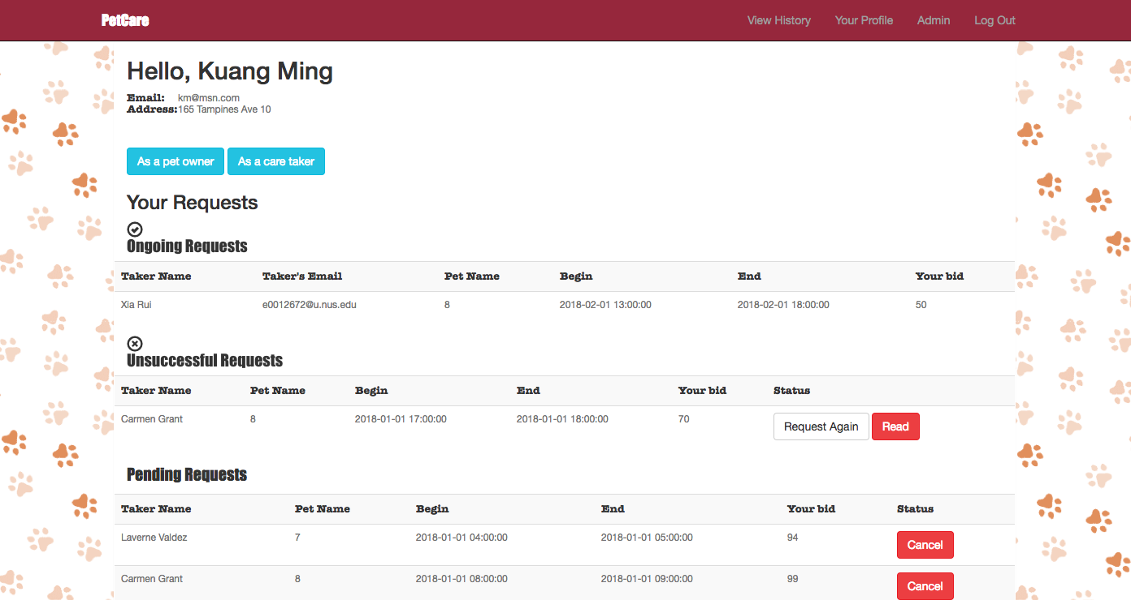

5.2 Pet Taker Dashboard

* Show all ongoing/pending request:

**SELECT** r.request_id, u.name, u.email, r.care_begin, r.care_end,

r.remarks, r.bids, p.pet_name, c.age, c.size, c.species

**FROM** request r, pet p, petcategory c, pet_user u

**WHERE** r.taker_id = $user_id **AND** r.status = 'pending'

**AND** r.care_begin > CURRENT_TIMESTAMP **AND** p.pets_id = r.pets_id

**AND** p.pcat_id = c.pcat_id **AND** u.user_id = r.owner_id

**AND** p.is_deleted = false

**ORDER** **BY** r.bids DESC;

r.status = ‘successful’ or ‘pending’ accordingly in ongoing/pending requests

* Reject:

**UPDATE** request **SET** status = 'failed' **WHERE** request_id =$reject_id;

* Before Accept check #overlap request:

**SELECT** **COUNT**(*) **FROM** request r1,request r2

**WHERE** r1.request_id = $accept_id **AND** r2.taker_id = $user_id

**AND** r2.status = 'successful'

**AND** r1.care_begin < r2.care_end **AND** r1.care_end > r2.care_begin;

* Accept and cancel all request with same pet and time overlap:

**UPDATE** request **SET** status = 'cancelled'

**WHERE** request_id <> $accept_id **AND** pets_id = $pets_id

**AND** '$start' < care_end **AND** '$end' > care_begin;

* Show all available slot

**SELECT** a.avail_id, a.start_time, a.end_time, a.remarks, p.species,

p.size, p.age

**FROM** availability a, petcategory p

**WHERE** a.pcat_id = p.pcat_id **AND** a.taker_id =$user_id

**AND** a.is_deleted = FALSE **AND** a.start_time > CURRENT_TIMESTAMP

**ORDER BY** a.start_time;

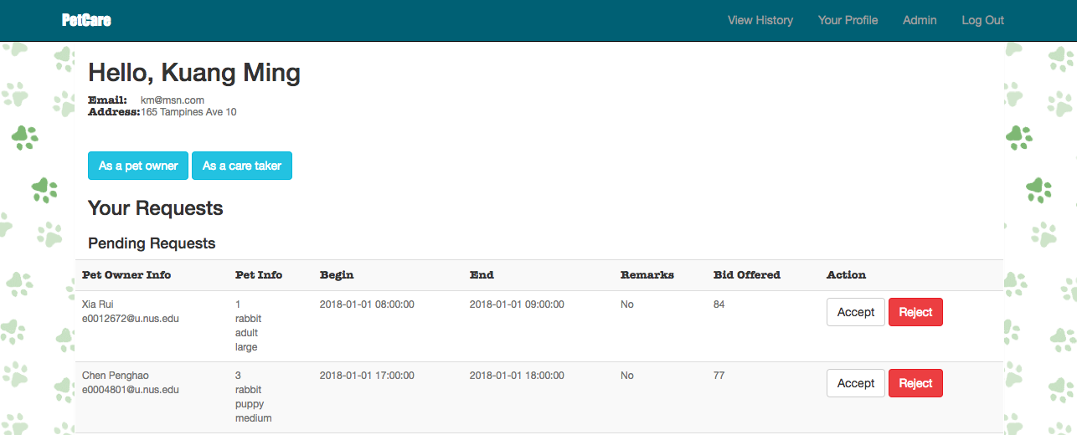

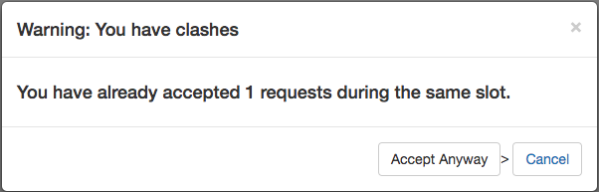

5.3 Send Request

* Search without any constraint:

**SELECT** a.avail_id, a.start_time, a.end_time, a.taker_id, p.name,

(**CASE WHEN** t.avgbids **is NULL THEN** 0 **ELSE** t.avgbids **END**) **AS** avgbids,

a.remarks

**FROM** (availability a **INNER JOIN** pet_user p **ON** p.user_id = a.taker_id

**AND** a.is_deleted = FALSE **AND** p.is_deleted = FALSE)

**LEFT JOIN** requesttime **AS** t **ON** a.taker_id = t.taker_id

**WHERE** a.taker_id <> '$user_id'

* When pet/start-time/end-time specified:

**AND** a.pcat_id = $pcat_id

**AND** a.start_time <= '$start_time'

**AND** a.end_time >= '$end_time'

* When all the above three specified:

**AND** a.taker_id **NOT IN** (**SELECT** r.taker_id **FROM** request r **WHERE** r.care_end >

'$start_time' **AND** r.care_begin < '$end_time' **AND** r.pets_id

= $pet_id **AND** r.status='pending')

* When preferred taker_name specified:

**AND** **UPPER**(p.name) **LIKE UPPER**('**%**$taker_name**%**')

* When average bids/hour range specified:

**AND** (t.avgbids <= $upperbound **OR** t.avgbids is **NULL**)

**AND** (t.avgbids >= $lowerbound **OR** t.avgbids is **NULL**)

* When owner do not want new takers: **AND** t.avgbids is **NOT NULL**
* Added in the end: **ORDER BY** avgbids **ASC;**
* Before sending requests, check the pet has not been taken care of in the specific period:

**SELECT * FROM** request r **WHERE** r.care_begin <'$end_time' **AND** r.care_end > '$start_time' **AND** r.pets_id = $pet_id **AND** r.status = 'successful';

* Finally send the request:

**INSERT INTO** request(owner_id, taker_id, care_begin, care_end, remarks, bids, pets_id) **VALUES** ($user_id, $taker_id, '$start_time', '$end_time', '$remarks', $bids, $pet_id);

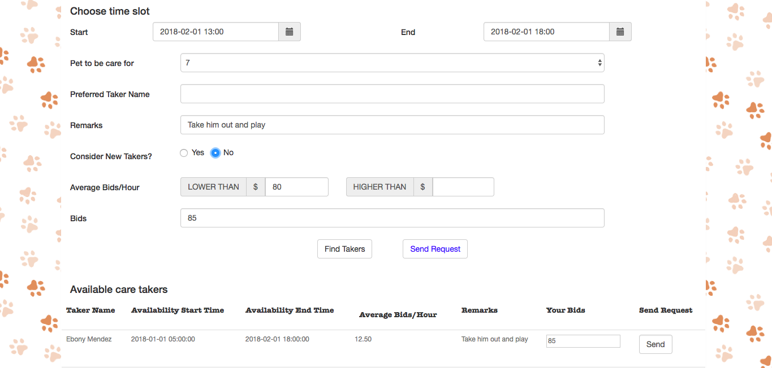

5.4 Admin

* Group all the successful request by timeslots(morning/afternoon/evening) and pet species
* For each group, find total #successful request, average bids/hour, and users that posts most

**SELECT** k.species, k.timeslot, k.RequestNum, k.average, r1.owner_id, k.totaltime

**FROM** (**SELECT** c.species **AS** species, r.slot **AS** timeslot,

**COUNT**(r.request_id) **AS** RequestNum,

(**SUM**(r.totaltime)/60) **AS** totaltime,

(**SUM**(r.bids)/**SUM**(r.totaltime)*60) **AS** average

**FROM** petcategory c, pet p, request r

**WHERE** r.pets_id = p.pets_id **AND** c.pcat_id = p.pcat_id

**AND** r.status = 'successful'

**GROUP BY** r.slot, c.species) **AS** k, request r1, petcategory c1, pet p1

**WHERE** r1.pets_id = p1.pets_id **AND** c1.pcat_id = p1.pcat_id

**AND** r1.status = 'successful' **AND** c1.species = k.species

**AND** r1.slot = k.timeslot

**GROUP BY** r1.owner_id, k.species, k.timeslot, k.RequestNum, k.average, k.totaltime

**HAVING** **COUNT**(**\***) >= **ALL**( **SELECT** **COUNT**(**\***)

**FROM** request r2, petcategory c2, pet p2

**WHERE** r2.pets_id = p2.pets_id **AND** c2.pcat_id = p2.pcat_id

**AND** r2.status = 'successful'

**AND** c2.species = k.species **AND** r2.slot = k.timeslot

**GROUP BY** r2.owner_id)

**ORDER BY** k.RequestNum **DESC**;

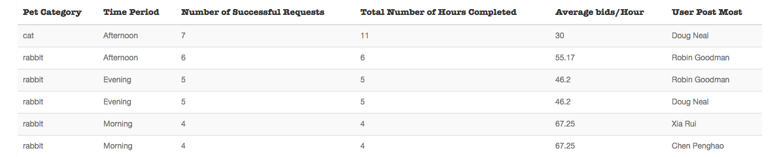

* Find the average bids/hour… of takers who have taken care of all pet species

**SELECT u.name, (SUM(r1.bids)/SUM(r1.totaltime)*60) AS average, SUM(r1.totaltime)  
FROM request r1, pet_user u  
WHERE r1.taker_id = u.user_id AND r1.status = 'successful'**

**AND NOT EXISTS (SELECT c1.species  
 FROM petcategory c1  
 WHERE NOT EXISTS (SELECT *  
 FROM request r2, pet p, petcategory c2  
 WHERE r2.taker_id = r1.taker_id  
 AND r2.pets_id = p.pets_id  
 AND p.pcat_id = c2.pcat_id  
 AND c2.species = c1.species  
 AND r2.status = 'successful'))**

**GROUP BY r1.taker_id, u.name  
ORDER BY average DESC;**

* For all takers, find the takers with highest average bids/hour
* For every species, find the takers with highest average bids/hour

**SELECT** u.name, u.email, k.average, k.num  
**FROM** (SELECT r.taker_id **AS** id, (SUM(r.bids)/SUM(r.totaltime)*60) **AS** average,

(**SUM**(r.totaltime)/60) **AS** num  
 **FROM** request r **WHERE** r.status = 'successful'  
 **GROUP BY** r.taker_id) **AS** k, pet_user u  
**WHERE** u.user_id = k.id **AND NOT EXISTS**(**SELECT** *  
 **FROM** (**SELECT**

(**SUM**(r1.bids)/**SUM**(r1.totaltime)*60) **AS**

avg **FROM** request r1

**GROUP BY** r1.taker_id) **AS** k1   
 **WHERE** k.average < k1.avg);

**SELECT** k.species, u.name, u.email, k.average, k.num

**FROM** (**SELECT** r.taker_id AS id, (**SUM**(r.bids)/**SUM**(r.totaltime)*60) **AS** average,

(**SUM**(r.totaltime)/60) **AS** num, c.species **AS** species

**FROM** request r, pet p, petcategory c

**WHERE** r.pets_id = p.pets_id **AND** p.pcat_id = c.pcat_id

**AND** r.status = 'successful'

**GROUP BY** c.species, r.taker_id) **AS** k, pet_user u

**WHERE** u.user_id = k.id **AND NOT EXISTS**(

**SELECT * FROM** (**SELECT** (**SUM**(r1.bids)/**SUM**(r1.totaltime)*60) **AS** avg

**FROM** request r1, pet p1, petcategory c1

**WHERE** r1.pets_id = p1.pets_id

**AND** p1.pcat_id = c1.pcat_id

**AND** c1.species = k.species

**AND** r1.status = 'successful'

**GROUP BY** r1.taker_id) AS k1

**WHERE** k.average < k1.avg);

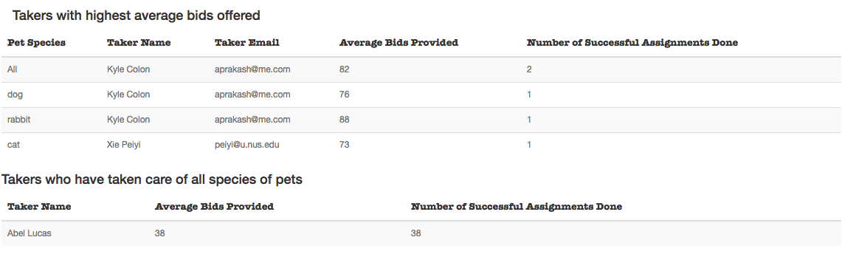

1. **Sample Data**
   1. **Pet Users**

**INSERT INTO** pet_user(**name**, **password**, **email**, **address**, **role**) **VALUES** (**'Xia Rui'**,12345,**'e0012672@u.nus.edu'**,**'30 Ang Mo Kio Ave 8'**, **'admin'**);  
**INSERT INTO** pet_user(**name**, **password**, **email**, **address**, **role**) **VALUES** (**'Chen Penghao'**,12345,**'e0004801@u.nus.edu'**,**'33 Lorong 2 Toa Payoh'**, **'admin'**);  
**INSERT INTO** pet_user(**name**, **password**, **email**, **address**, **role**) **VALUES** (**'Xie Peiyi'**,12345,**'peiyi@u.nus.edu'**,**'55 Hougang Ave 10'**, **'admin'**);  
**INSERT INTO** pet_user(**name**, **password**, **email**, **address**, **role**) **VALUES** (**'Kuang Ming'**,12345,**'km@msn.com'**,**''**, **'admin'**);  
  
**INSERT INTO** pet_user(**name**, **password**, **email**, **address**) **VALUES** (**'Patti Dennis'**,12345,**'empathy@msn.com'**,**'157 Foxrun Street Newnan, GA 30263'**);  
**INSERT INTO** pet_user(**name**, **password**, **email**, **address**) **VALUES** (**'Carmen Grant'**,23456,**'presoff@hotmail.com'**,**'9 South Surrey Street Rockford, MI 49341'**);  
**INSERT INTO** pet_user(**name**, **password**, **email**, **address**) **VALUES** (**'Abel Lucas'**,34567,**'keijser@optonline.net'**,**'930 Storm Court Washington, PA 15301'**);  
**INSERT INTO** pet_user(**name**, **password**, **email**, **address**) **VALUES** (**'Marguerite Jennings'**,45678,**'curly@gmail.com'**,**'508 E. Longfellow Rd. Revere, MA 02151'**);  
**INSERT INTO** pet_user(**name**, **password**, **email**, **address**) **VALUES** (**'Samuel Lawrence'**,56789,**'squirrel@aol.com'**,**'8807 Aurora Road Ogden, UT 84404'**);  
**INSERT INTO** pet_user(**name**, **password**, **email**, **address**) **VALUES** (**'Lydia Turner'**,67900,**'cantu@verizon.net'**,**'29 Paradise Court Moorhead, MN 56560'**);  
**INSERT INTO** pet_user(**name**, **password**, **email**, **address**) **VALUES** (**'Eloise Cooper'**,79011,**'pajas@msn.com'**,**'9267 1st St. Wenatchee, WA 98801'**);  
**INSERT INTO** pet_user(**name**, **password**, **email**, **address**) **VALUES** (**'Maxine Ramos'**,90122,**'vertigo@aol.com'**,**'671 Liberty Dr. Ankeny, IA 50023'**);  
**INSERT INTO** pet_user(**name**, **password**, **email**, **address**) **VALUES** (**'Kyle Colon'**,12334,**'aprakash@me.com'**,**'49 Walt Whitman Street Apopka, FL 32703'**);  
**INSERT INTO** pet_user(**name**, **password**, **email**, **address**) **VALUES** (**'Laverne Valdez'**,12344,**'lishoy@verizon.net'**,**'12 Bald Hill Street Norfolk, VA 23503'**);  
**INSERT INTO** pet_user(**name**, **password**, **email**, **address**) **VALUES** (**'David Reynolds'**,23455,**'marnanel@hotmail.com'**,**'224 Second Drive Cocoa, FL 32927'**);  
**INSERT INTO** pet_user(**name**, **password**, **email**, **address**) **VALUES** (**'Clyde Mack'**,34566,**'smartfart@verizon.net'**,**'870 Addison Court Dacula, GA 30019'**);  
**INSERT INTO** pet_user(**name**, **password**, **email**, **address**) **VALUES** (**'Cameron Huff'**,45677,**'petersko@yahoo.ca'**,**'7834 Ann Street Quincy, MA 02169'**);  
**INSERT INTO** pet_user(**name**, **password**, **email**, **address**) **VALUES** (**'Ebony Mendez'**,56788,**'avalon@att.net'**,**'8789 Hart St. Ballston Spa, NY 12020'**);  
**INSERT INTO** pet_user(**name**, **password**, **email**, **address**) **VALUES** (**'Joe Munoz'**,67899,**'ournews@live.com'**,**'94 Meadowbrook St.Apt 36 Florence, SC 29501'**);  
**INSERT INTO** pet_user(**name**, **password**, **email**, **address**) **VALUES** (**'Travis Pearson'**,79010,**'chaffar@mac.com'**,**'436 E. Second Avenue Missoula, MT 59801'**);  
**INSERT INTO** pet_user(**name**, **password**, **email**, **address**) **VALUES** (**'Robin Goodman'**,90121,**'mdielmann@hotmail.com'**,**'11 Brewer Road Chardon, OH 44024'**);  
**INSERT INTO** pet_user(**name**, **password**, **email**, **address**) **VALUES** (**'Marcus Gilbert'**,81232,**'weazelman@yahoo.com'**,**'12 Summerhouse St. Hoboken, NJ 07030'**);  
**INSERT INTO** pet_user(**name**, **password**, **email**, **address**) **VALUES** (**'Doug Neal'**,12343,**'msloan@me.com'**,**'5 East Proctor Street Missoula, MT 59801'**);  
**INSERT INTO** pet_user(**name**, **password**, **email**, **address**) **VALUES** (**'Josephine Erickson'**,23454,**'goresky@msn.com'**,**'7943 East Lakeshore Street Rockford, MI 49341'**);

* 1. **Pet Categories**

**INSERT INTO** petcategory (**age**, **size**, **species**) **VALUES** (**'puppy'**,**'small'**,**'cat'**);  
**INSERT INTO** petcategory (**age**, **size**, **species**) **VALUES** (**'puppy'**,**'small'**,**'dog'**);  
**INSERT INTO** petcategory (**age**, **size**, **species**) **VALUES** (**'puppy'**,**'small'**,**'rabbit'**);  
**INSERT INTO** petcategory (**age**, **size**, **species**) **VALUES** (**'puppy'**,**'medium'**,**'cat'**);  
**INSERT INTO** petcategory (**age**, **size**, **species**) **VALUES** (**'puppy'**,**'medium'**,**'dog'**);  
**INSERT INTO** petcategory (**age**, **size**, **species**) **VALUES** (**'puppy'**,**'medium'**,**'rabbit'**);  
**INSERT INTO** petcategory (**age**, **size**, **species**) **VALUES** (**'puppy'**,**'large'**,**'cat'**);  
**INSERT INTO** petcategory (**age**, **size**, **species**) **VALUES** (**'puppy'**,**'large'**,**'dog'**);  
**INSERT INTO** petcategory (**age**, **size**, **species**) **VALUES** (**'puppy'**,**'large'**,**'rabbit'**);  
**INSERT INTO** petcategory (**age**, **size**, **species**) **VALUES** (**'puppy'**,**'giant'**,**'cat'**);  
**INSERT INTO** petcategory (**age**, **size**, **species**) **VALUES** (**'puppy'**,**'giant'**,**'dog'**);  
**INSERT INTO** petcategory (**age**, **size**, **species**) **VALUES** (**'puppy'**,**'giant'**,**'rabbit'**);  
**INSERT INTO** petcategory (**age**, **size**, **species**) **VALUES** (**'adult'**,**'small'**,**'cat'**);  
**INSERT INTO** petcategory (**age**, **size**, **species**) **VALUES** (**'adult'**,**'small'**,**'dog'**);  
**INSERT INTO** petcategory (**age**, **size**, **species**) **VALUES** (**'adult'**,**'small'**,**'rabbit'**);  
**INSERT INTO** petcategory (**age**, **size**, **species**) **VALUES** (**'adult'**,**'medium'**,**'cat'**);  
**INSERT INTO** petcategory (**age**, **size**, **species**) **VALUES** (**'adult'**,**'medium'**,**'dog'**);  
**INSERT INTO** petcategory (**age**, **size**, **species**) **VALUES** (**'adult'**,**'medium'**,**'rabbit'**);  
**INSERT INTO** petcategory (**age**, **size**, **species**) **VALUES** (**'adult'**,**'large'**,**'cat'**);  
**INSERT INTO** petcategory (**age**, **size**, **species**) **VALUES** (**'adult'**,**'large'**,**'dog'**);  
**INSERT INTO** petcategory (**age**, **size**, **species**) **VALUES** (**'adult'**,**'large'**,**'rabbit'**);  
**INSERT INTO** petcategory (**age**, **size**, **species**) **VALUES** (**'adult'**,**'giant'**,**'cat'**);  
**INSERT INTO** petcategory (**age**, **size**, **species**) **VALUES** (**'adult'**,**'giant'**,**'dog'**);  
**INSERT INTO** petcategory (**age**, **size**, **species**) **VALUES** (**'adult'**,**'giant'**,**'rabbit'**);

* 1. **Pets**

**INSERT INTO** pet(**pcat_id**, **owner_id**, **pet_name**) **VALUES** (2,1,**'Ah Beng'**);  
**INSERT INTO** pet(**pcat_id**, **owner_id**, **pet_name**) **VALUES** (3,5,**'Ah Lian'**);  
**INSERT INTO** pet(**pcat_id**, **owner_id**, **pet_name**) **VALUES** (5,4,**'Ah Hong'**);  
**INSERT INTO** pet(**pcat_id**, **owner_id**, **pet_name**) **VALUES** (1,2,**'Ah Ben'**);  
**INSERT INTO** pet(**pcat_id**, **owner_id**, **pet_name**) **VALUES** (4,8,**'Ah Wong'**);  
**INSERT INTO** pet(**pcat_id**, **owner_id**, **pet_name**) **VALUES** (7,3,**'Ah Kay'**);  
**INSERT INTO** pet(**pcat_id**, **owner_id**, **pet_name**) **VALUES** (2,9,**'Ah Seng'**);  
**INSERT INTO** pet(**pcat_id**, **owner_id**, **pet_name**) **VALUES** (5,6,**'Ah Leong'**);  
**INSERT INTO** pet(**pcat_id**, **owner_id**, **pet_name**) **VALUES** (2,10,**'Ah Mah'**);  
**INSERT INTO** pet(**pcat_id**, **owner_id**, **pet_name**) **VALUES** (8,7,**'Ah Wai'**);

* 1. **Availabilities**

1. **INSERT INTO** availability(**start_time**, **end_time**, **pcat_id**, **taker_id**) **VALUES** (**'2018-01-01 00:00:00'**,**'2018-02-01 01:00:00'**,3,1);  
   **INSERT INTO** availability(**start_time**, **end_time**, **pcat_id**, **taker_id**) **VALUES** (**'2018-01-01 18:00:00'**,**'2018-01-21 20:00:00'**,3,1);  
   **INSERT INTO** availability(**start_time**, **end_time**, **pcat_id**, **taker_id**) **VALUES** (**'2018-01-01 23:00:00'**,**'2018-02-01 01:00:00'**,3,1);  
   **INSERT INTO** availability(**start_time**, **end_time**, **pcat_id**, **taker_id**) **VALUES** (**'2018-01-01 17:00:00'**,**'2018-02-01 19:00:00'**,3,1);  
   **INSERT INTO** availability(**start_time**, **end_time**, **pcat_id**, **taker_id**) **VALUES** (**'2018-01-01 22:00:00'**,**'2018-02-01 23:00:00'**,3,1);  
   **INSERT INTO** availability(**start_time**, **end_time**, **pcat_id**, **taker_id**) **VALUES** (**'2018-01-01 00:00:00'**,**'2018-02-01 01:00:00'**,9,1);  
   **INSERT INTO** availability(**start_time**, **end_time**, **pcat_id**, **taker_id**) **VALUES** (**'2018-01-01 20:00:00'**,**'2018-02-01 01:00:00'**,9,1);  
   **INSERT INTO** availability(**start_time**, **end_time**, **pcat_id**, **taker_id**) **VALUES** (**'2018-01-01 22:00:00'**,**'2018-02-01 00:00:00'**,9,1);  
   **INSERT INTO** availability(**start_time**, **end_time**, **pcat_id**, **taker_id**) **VALUES** (**'2018-01-01 12:00:00'**,**'2018-02-01 13:00:00'**,9,1);  
   **INSERT INTO** availability(**start_time**, **end_time**, **pcat_id**, **taker_id**) **VALUES** (**'2018-01-01 19:00:00'**,**'2018-02-01 21:00:00'**,9,1);  
   **INSERT INTO** availability(**start_time**, **end_time**, **pcat_id**, **taker_id**) **VALUES** (**'2018-01-01 00:00:00'**,**'2018-02-01 10:00:00'**,13,1);  
   **INSERT INTO** availability(**start_time**, **end_time**, **pcat_id**, **taker_id**) **VALUES** (**'2018-01-01 17:00:00'**,**'2018-02-01 23:00:00'**,13,1);  
   **INSERT INTO** availability(**start_time**, **end_time**, **pcat_id**, **taker_id**) **VALUES** (**'2018-01-01 17:00:00'**,**'2018-02-01 19:00:00'**,13,1);  
   **INSERT INTO** availability(**start_time**, **end_time**, **pcat_id**, **taker_id**) **VALUES** (**'2018-01-01 09:00:00'**,**'2018-02-01 11:00:00'**,13,1);  
   **INSERT INTO** availability(**start_time**, **end_time**, **pcat_id**, **taker_id**) **VALUES** (**'2018-01-01 10:00:00'**,**'2018-02-01 12:00:00'**,13,1);  
   **INSERT INTO** availability(**start_time**, **end_time**, **pcat_id**, **taker_id**) **VALUES** (**'2018-01-01 06:00:00'**,**'2018-02-01 17:00:00'**,19,1);  
   **INSERT INTO** availability(**start_time**, **end_time**, **pcat_id**, **taker_id**) **VALUES** (**'2018-01-01 14:00:00'**,**'2018-02-01 20:00:00'**,19,1);  
   **INSERT INTO** availability(**start_time**, **end_time**, **pcat_id**, **taker_id**) **VALUES** (**'2018-01-01 23:00:00'**,**'2018-02-01 00:00:00'**,19,1);  
   **INSERT INTO** availability(**start_time**, **end_time**, **pcat_id**, **taker_id**) **VALUES** (**'2018-01-01 06:00:00'**,**'2018-02-01 09:00:00'**,19,1);  
   **INSERT INTO** availability(**start_time**, **end_time**, **pcat_id**, **taker_id**) **VALUES** (**'2018-01-01 22:00:00'**,**'2018-02-01 23:00:00'**,19,1);
   1. **Requests**
2. **INSERT INTO** request(**owner_id**, **taker_id**, **care_begin**, **care_end**, **remarks**, **bids**, **pets_id**) **VALUES** (19,9,**'2018-01-01 09:00:00'**,**'2018-01-01 10:00:00'**,**'No'**,3,38);  
   **INSERT INTO** request(**owner_id**, **taker_id**, **care_begin**, **care_end**, **remarks**, **bids**, **pets_id**) **VALUES** (19,22,**'2018-01-01 03:00:00'**,**'2018-01-01 04:00:00'**,**'No'**,26,38);  
   **INSERT INTO** request(**owner_id**, **taker_id**, **care_begin**, **care_end**, **remarks**, **bids**, **pets_id**) **VALUES** (19,12,**'2018-01-01 09:00:00'**,**'2018-01-01 10:00:00'**,**'No'**,63,38);  
   **INSERT INTO** request(**owner_id**, **taker_id**, **care_begin**, **care_end**, **remarks**, **bids**, **pets_id**) **VALUES** (20,6,**'2018-01-01 06:00:00'**,**'2018-01-01 07:00:00'**,**'No'**,59,39);  
   **INSERT INTO** request(**owner_id**, **taker_id**, **care_begin**, **care_end**, **remarks**, **bids**, **pets_id**) **VALUES** (20,22,**'2018-01-01 20:00:00'**,**'2018-01-01 21:00:00'**,**'No'**,13,39);  
   **INSERT INTO** request(**owner_id**, **taker_id**, **care_begin**, **care_end**, **remarks**, **bids**, **pets_id**) **VALUES** (20,18,**'2018-01-01 14:00:00'**,**'2018-01-01 15:00:00'**,**'No'**,30,39);  
   **INSERT INTO** request(**owner_id**, **taker_id**, **care_begin**, **care_end**, **remarks**, **bids**, **pets_id**) **VALUES** (20,22,**'2018-01-01 05:00:00'**,**'2018-01-01 06:00:00'**,**'No'**,1,40);  
   **INSERT INTO** request(**owner_id**, **taker_id**, **care_begin**, **care_end**, **remarks**, **bids**, **pets_id**) **VALUES** (20,24,**'2018-01-01 01:00:00'**,**'2018-01-01 02:00:00'**,**'No'**,7,40);  
   **INSERT INTO** request(**owner_id**, **taker_id**, **care_begin**, **care_end**, **remarks**, **bids**, **pets_id**, **status**) **VALUES** (20,22,**'2018-01-01 16:00:00'**,**'2018-01-01 17:00:00'**,**'No'**,36,40,**'successful'**);  
   **INSERT INTO** request(**owner_id**, **taker_id**, **care_begin**, **care_end**, **remarks**, **bids**, **pets_id**, **status**) **VALUES** (21,20,**'2018-01-01 17:00:00'**,**'2018-01-01 18:00:00'**,**'No'**,64,41,**'successful'**);  
   **INSERT INTO** request(**owner_id**, **taker_id**, **care_begin**, **care_end**, **remarks**, **bids**, **pets_id**, **status**) **VALUES** (21,21,**'2018-01-01 12:00:00'**,**'2018-01-01 13:00:00'**,**'No'**,62,41,**'successful'**);  
   **INSERT INTO** request(**owner_id**, **taker_id**, **care_begin**, **care_end**, **remarks**, **bids**, **pets_id**, **status**) **VALUES** (21,21,**'2018-01-01 06:00:00'**,**'2018-01-01 07:00:00'**,**'No'**,41,41,**'successful'**);  
   **INSERT INTO** request(**owner_id**, **taker_id**, **care_begin**, **care_end**, **remarks**, **bids**, **pets_id**, **status**) **VALUES** (21,13,**'2018-01-01 23:00:00'**,**'2018-01-02 00:00:00'**,**'No'**,88,42,**'successful'**);  
   **INSERT INTO** request(**owner_id**, **taker_id**, **care_begin**, **care_end**, **remarks**, **bids**, **pets_id**, **status**) **VALUES** (21,19,**'2018-01-01 21:00:00'**,**'2018-01-01 22:00:00'**,**'No'**,33,42,**'successful'**);